CSCI 6212: Project 3
2025-11-21

Problem Statement
Box Stacking. You are given a set of n types of rectangular 3-D boxes, where the i^th box has height h(i), width w(i) and depth d(i) (all real numbers). You want to create a stack of boxes which is as tall as possible, but you can only stack a box on top of another box if the dimensions of the 2-D base of the lower box are each strictly larger than those of the 2-D base of the higher box. Of course, you can rotate a box so that any side functions as its base. It is also allowable to use multiple instances of the same type of box.

Intuitive Explanation of algorithm
- From the n box types generate m box types by rotating each type. There are at most 6 unique rotations per box type, so m<=6n. For example, suppose one box type has height 1, width 2, and depth 3 (1x2x3). Rotation creates an additional 5 box types: 1x3x2, 2x1x3, 2x3x1, 3x1x2, 3x2x1
- Sort the m rotated box types by increasing width.
- After arranging the m rotated box types by increasing width, define a[i] for i=1,…,m as the maximum height achievable using the i-th box as the base. After sorting by increasing width, you can’t stack any box b[j] on top of any box b[i] when j>=i since w[j]>=w[i]. This also implies each box type can only be used once at the most in a stack. The maximum height is max{a[i] | i=1,…,m}
a[1] = height[1]
For i>1 a[i] = max{a[k] | k<i and width[k]<width[i] and depth[k]<depth[i]} + height[i]
In words the maximum height achievable using the i-th box type as the base is the height of the i-th box plus the maximum of the maximum stack heights achievable using boxes of smaller width and smaller depth as bases.

Pseudocode
findMaxHeight = function(boxes) {
// rotate
boxes = rotateBoxes(boxes)
//sort box types by increasing width
boxes = sort(boxes, by='width')
//define arrays for each dimension
n = length(boxes)
height = boxes['height']
width = boxes['width']
depth = boxes['depth']
//initialize array
a = new array[n]
//initialize max height of stacked boxes as 0
overall_max = 0
//base case
a[0] = height[0]
//iterate through boxes defining array a[i] and also updating overall_max
for (i = 1 to n) {
//find max of a[k] for k<i such that width[k]<width[i] and depth[k]<depth[i]
max = 0
for (k<i) {
if (width[k]<width[i] & depth[k]<depth[i] & a[k]>max1) {
max = a[k]
}
}
//define a[i] as the max a[k] from above plus height[i]
a[i] = max + height[i]
//Update overall_max if necessary
if (a[i]>overall_max) {overall_max=a[i]}
}
return overall_max
}

Time Complexity
The time required for this algorithm is the time required is:
- Rotate boxes n boxes - O(n)
- Sort 6n boxes by increasing width - O(n log n)
- Compute a[i] for i=1,…,m and keep track of the max{a[i] | i=1,…,m} - O(n^2)
Therefore, the overall time complexity is O(n^2)

Experimental Analysis
The two graphs below plot the run time in nanoseconds for different values of n or log(n). n is between 10 and 25,000. For each value of n, the experimental time that the algorithm required to complete was measured.
For each value of n, the theoretical time was calculated as (n^2)*70. The theoretical values were multiplied by 70 which was approximately the median of ratio between n^2 and the actual run time in nanoseconds.
The theoretical values are shown in blue and the experimental values are shown in orange. In both plots the experimental curve is similar to the theoretical curve until n=23900. For the largest two values of n tested, runtime is longer than expected. But for n<23000 the experimental results are consistent with a time complexity of n^2.
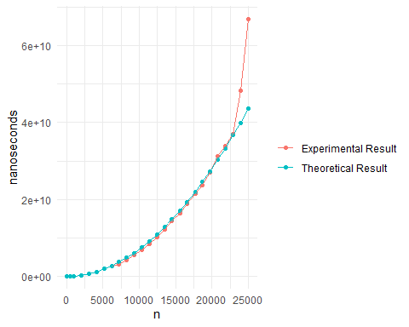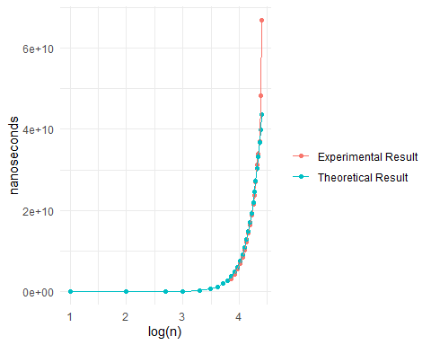

Data
n | Time (ns) | 70*n^2
10 | 9162200 | 7000
100 | 7696700 | 700000
500 | 32072200 | 17500000
1000 | 78003700 | 70000000
2000 | 284678200 | 280000000
3100 | 629638900 | 672700000
4100 | 1120280400 | 1176700000
5200 | 1878638600 | 1892800000
6200 | 2564288800 | 2690800000
7200 | 3109225500 | 3628800000
8300 | 4247709100 | 4822300000
9300 | 5483513800 | 6054300000
10400 | 6929596100 | 7571200000
11400 | 8414630200 | 9097200000
12500 | 10271770600 | 10937500000
13500 | 12088679200 | 12757500000
14500 | 14452499600 | 14717500000
15600 | 16434300700 | 17035200000
16600 | 18925479000 | 19289200000
17700 | 21494650600 | 21930300000
18700 | 23663257100 | 24478300000
19700 | 26934402800 | 27166300000
20800 | 31156224300 | 30284800000
21800 | 33853563000 | 33266800000
22900 | 37049789300 | 36708700000
23900 | 48332600800 | 39984700000
25000 | 66945694900 | 43750000000

Github Link
https://github.com/gituser5438/CSCI-6212-Project-3

